**Advance Excel Assignment 1**

1. What do you mean by cells in an excel sheet?

1. How can you restrict someone from copying a cell from your worksheet?

1. How to move or copy the worksheet into another workbook?

1. Which key is used as a shortcut for opening a new window document?

1. What are the things that we can notice after opening the Excel interface?

1. When to use a relative cell reference in excel?

xxxxxxxxxxxxxxxxxxxxxxxxxxxxxxxxxxxxxxxxxxxxxxxxxxxxxxxxxxxxxxxxxxxxxxxxxxxxxxxxxxxxxxxxxxxxxxxxx

1. **What do you mean by cells in an excel sheet?**

**Ans:** A cell is a rectangular box that occurs at the intersection of a vertical column and a horizontal row in an excel worksheet where we can add values or write formulas to make the calculations better and find out the actual analysis of the data.

Like columns A, B, C so on, and Rows 1,2,3, and so on. So, each cell can be defined as a combination of columns and rows like A2, B3

1. **How can you restrict someone from copying a cell from your worksheet?**

**Ans**: In order to protect the worksheet from getting copied, we need to go into Menu bar >Review > Protect sheet > Enter Password. By entering the password, the worksheet will be secured from getting copied by others.

1. **How to move or copy the worksheet into another workbook?**

**Ans:** Go to sheet, right-click, then select “Move or Copy”. Select the desired sheet that you want to copy or move and then, if you want to create a copy, click on the checkbox “Create a copy ” and press the OK button to create copy.

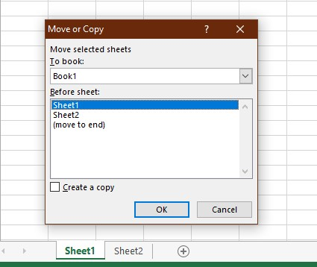

1. **Which key is used as a shortcut for opening a new window document?**

**Ans**: Ctrl + N will open a new window

1. **What are the things that we can notice after opening the Excel interface?**

**Ans:** Interface components of Excel 1. Quick Access Toolbar



1. Ribbon



1. Name Box



1. Formula Quick Menu



1. Formula Bar



1. Status Bar - left bottom side + The Sheets



1. Worksheet View options + Zoom Control with %– right bottom side



**6. When to use a relative cell reference in excel?**

Ans: Relative cell reference should be used whenever you need to repeat the same calculation across multiple rows or columns.